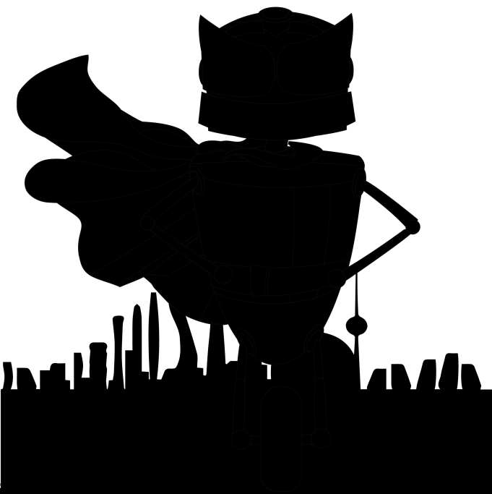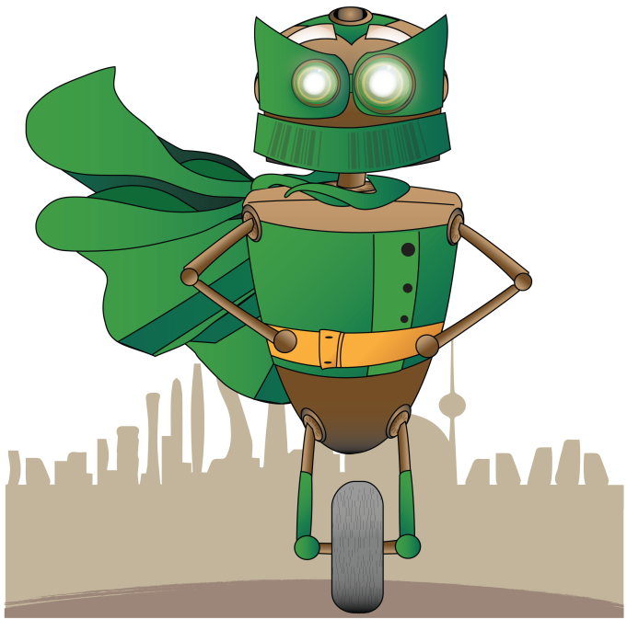

Both Battery Robots (full Version) – left is prior to reading 20 minutes, right image is after reading all 15 hours.

Art File names are numbered as follows:

|  |  |  |
| --- | --- | --- |
| 1 | 2 | 3 |
| 4 | 5 | 6 |
| 7 | 8 | 9 |
| ... | … | …45 |

Also, if possible, it would be great that after the robot is complete, a second image appears. This is the Battery Quote.png image and would look somewhat like this (on a second column?):

